Pass for level5: iX6IOfmpN7AYOQGPwtn3fXpbaJVJcHfq

Step 1:

I connect to the server with username and password and saw:

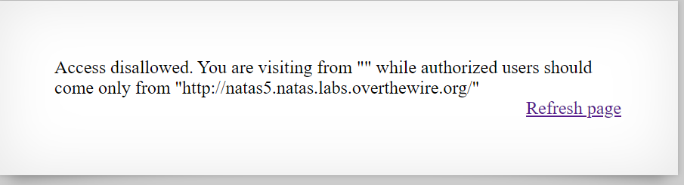 Step 2:

After I saw that there is nothing in the source code I realized that there is something to do with the http headers

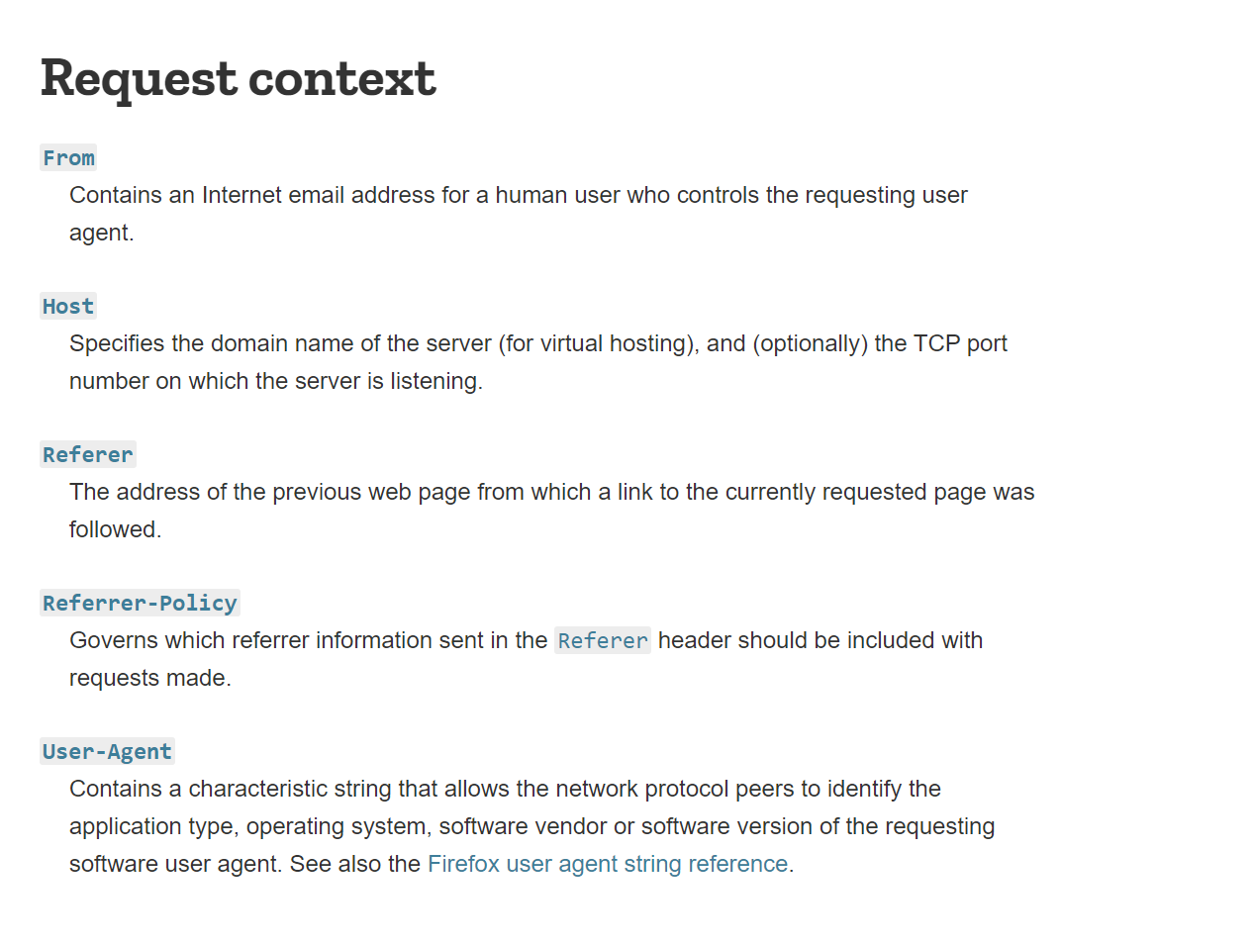

Step 3:

Then I created python program that mimic the linux command: "nslookup" called "requests.py".

Step 4:

I send requests with Referer = <http://natas5.natas.labs.overthewire.org/>

Step 5:

